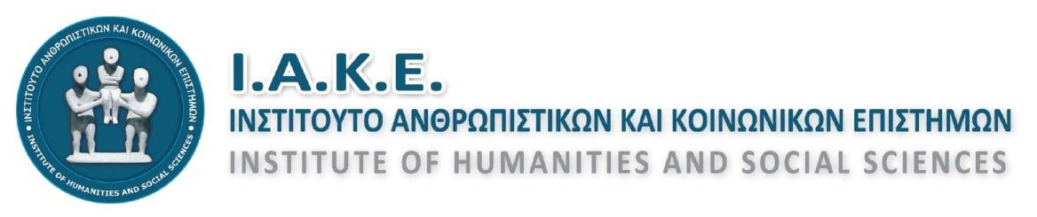
Address: 83-85, Evans St. (Office Α11),
71201, Heraklion, Crete
Tel/Fax No: 2815200045
Email: iakekriti@gmail.com
Website: http://www.iake.gr & http://iake.weebly.com

Heraklion, June 5th, 2020
Reg. No: 56

ANNOUNCEMENT

Subject: Organisation of 6th International Scientific Conference of the Institute of Humanities and Social Sciences.

Honorable Rapporteurs and Conferrers of the 6th International Scientific Conference,
We would like to inform you that ‘ all activities with the aim of organizing seminars’ are to restart on July 1st’ according to the formal announcement by the Ministry of Development and Investments referring to the de-escalation of applied lockdown measures due to the COVID-19 pandemic.
Following the above mentioned announcement, the Institute of Humanities and Social Sciences conclusively proceeds to the organization of the 6th International Scientific Conference on "Communication, information, information and education at later date modernity". The Conference will be held on July 10-12, 2020 at the premises of the Cultural and Conference Centre of the Municipality of Heraklion in Heraklion, Crete.
The conference will take place in the physical presence of both the conferrers and the participants and will abide by the regulations and protective measures as required.
Allowance will be made for lecturers who come from distant places and are not able to travel due to the restrictive measures to present their proposal online through videoconferencing.
Also, we would like to express our apology for being obliged to decline the physical presence and participation of rapporteurs and conferrers from abroad in the comingconference. However, lecturers from abroad can opt for giving their lecture online through videoconferencing if they wish.
Lecturers who wish to participate in the conference through videoconferencing due to being unable to be physically present at the conference are kindly requested to inform us by June 15, 2020 by e-mail to johntzortzakis@gmail.com .
In the case of videoconferencing, lecturers will receive detailed guidelines concerning connection and presentation process.
At this point, you are kindly reminded that all lecturers are expected to participate in the procedures throughout the conference due to the fact that a lecture can be included in any session or day of the conference.
As we are still at the organizing stage, lecturers wishing to participate on specific dates or at a specific time due to personal engagements or duties are requested to provide us well in advance with the specific dates or time they are available by e-mail to striligkas@gmail.com. It is hereby made known that no alteration will be possible once the programme of the conference is published.
We carry on with the proceedings feeling happy and optimistic about the successful organization of 6th International Scientific Conference of the Institute of Humanities and Social Sciences.

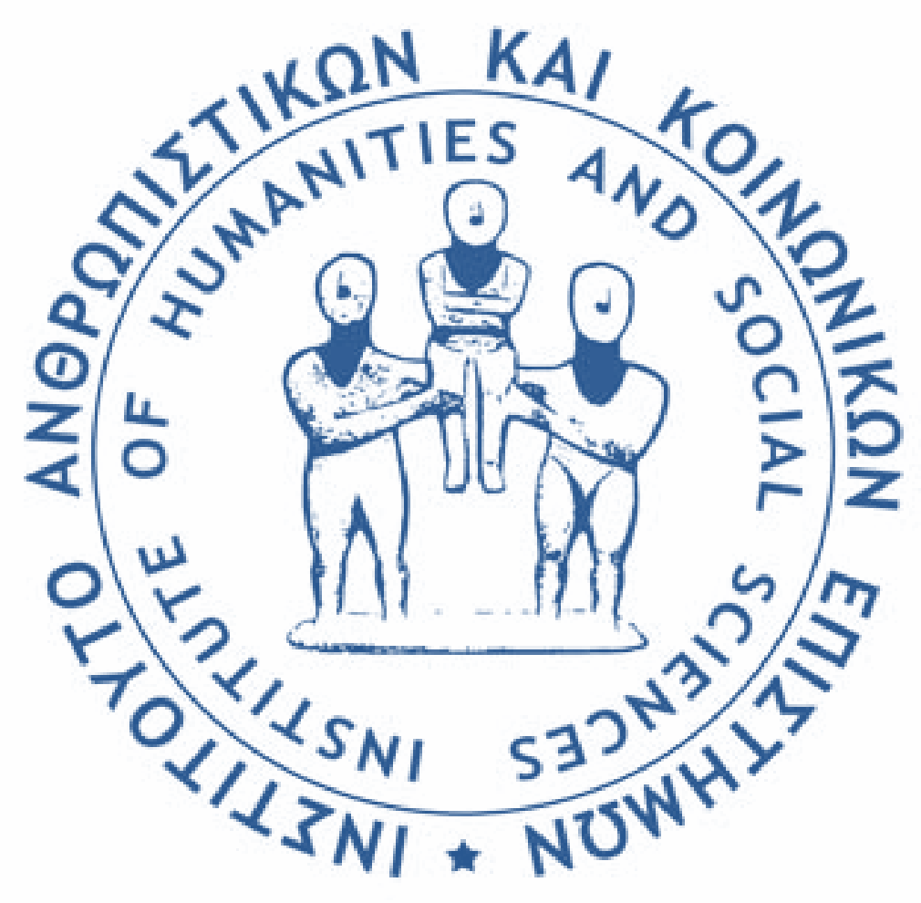
Kind regards,
On behalf of the Board
The President
Mrs Helen Maraki
Msc. PhD, Head of the Educational Advisory Centre

The Secretary
Mr George Striligas
Msc. Educational Coordinator

