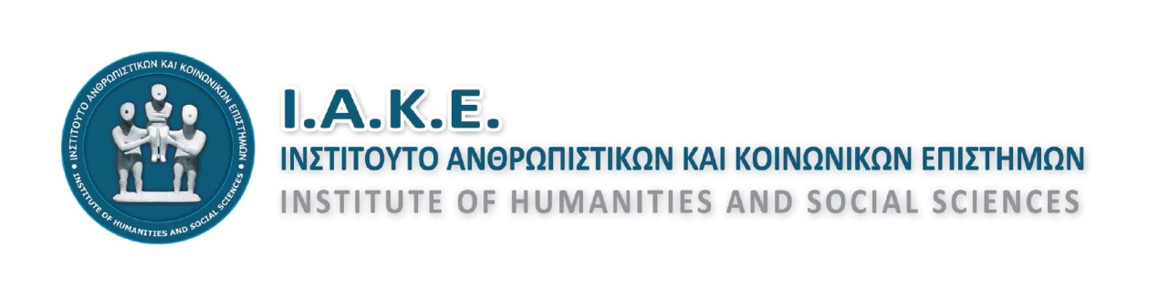
Address: Evans 83-85 (Desk A111), Postal Code: 71201, Heraklion, Crete
Telephone/Fax: 2815200045, Email: iakekriti@gmail.com
Websites: http://www.iake.gr & http://iake.weebly.com
facebook.com/iake.gr
Information:
Eleni Maraki, telephone 6942558286
Georgios Striligkas, telephone 6944712278

Heraklion, September 16, 2018

1^{η} ANNOUNCEMENT
5th INTERNATIONAL SCIENTIFIC CONFERENCE
Interdisciplinarity,
as a cognitive, educational, and social challenge
Heraklion, 5-7 April 2019
The institute of Humanitarian and Social Sciences (I.A.K.E.), after the successful accomplishment of four International Scientific Conferences, is glad to announce to its members, its collaborators, its friends, the scientific and educational community, and everyone that might be interested, that it is organizing the 5th International Scientific Conference with central topic:
“The interdisciplinarity as a cognitive, educational and social challenge”
The Conference will take place in Heraklion, Crete, from the 5th to 7th of April 2019.
The main aim of the Conference is to explore interdisciplinarity as a nowadays challenge, proposition, and practice in the field of scientific research, education, politics and society, at an individual and a collective level.
Key characteristics of the scientific progress nowadays are the enormous broadening of the human knowledge, the fragmentation of the scientific knowledge, and consequently the emphasis on the specialized training. Considerations regarding this phenomenon and its consequences have already been expressed from science’s establishment and they progress alongside; sometimes by emphasizing the demand for decentralization and specialization, and other times by underlining the demand for cooperation and composition considering every autonomization as alienation. Since the ancient times, Plato, in his work “Politeia”, had written about the interconnection of separate knowledge areas. During the Renaissance, Homo Universalis has been proposed as the ideal model; the person who is interested in all arts and sciences. Since the beginning of the 20th century, in the educational area, J. Dewey underlined that the students are not living in multiple separate worlds, but in one united world, where everything is interconnected. Nowadays, at the crossroad between theoretical and practical approaches, one experiences the tug of war between the general and the partial, the theory and the practice, the general education and the specialized training, the local and the universal. In this context, the concern regarding more cooperative, spherical and holistic approaches arises, and shows up the demand for launching interdisciplinarity as the antidote for overcoming conflicts and contradictions.
Can, perhaps, interdisciplinary lead to harmonic and functional conjunctions or is it a necessary evil due to the complexity of the social phenomena? Is it maybe a regression against the thorough and structured specialization? Which are the scientific and social reasons that drive the interdisciplinary approaches? Is the mutual understanding and the mutual update in between the scientists the major factor requested, or is it the development of more meaningful collaborations and compositions? Is the cooperation between different academic fields achievable? What could pedagogues and engineers, bio-scientists and philosophers, economists and mechanical engineers, natural scientists and writers -and so on- have in common? Is the cooperation required due to one useful end product or is it dictated by deeper existential and scientific reasons?
Having the aforementioned considerations as a starting point, the I.A.K.E Institute proceeds to the implementation of the 5th International Scientific Conference, hoping to highlight particular aspects of the issue and to become a forum for a fruitful scientific, educational and social dialogue for everyone who might be interested.

THEMATIC AREAS OF CONFERENCE
The Conference focuses its interest on the following thematic areas related to the interdisciplinarity, without excluding any other related thematic areas:
Theoretical approaches to interdisciplinarity
- Semantic, historic, social, and scientific context
- Views of humanitarian and social sciences
- Contemporary trends and policies, scientific research and practices
Educational theory and practice
- Pedagogical, educational, and teaching theory
- Policies on Education, Orientation and Structures of Education
- Curriculum, supportive and teaching materials
- Teaching methodology, teaching proposals, teaching scenarios
- General education, cross-thematic and specialized training
- Innovative projects, new technologies
- Training for sustainability, vocational guidance
- Special education and inclusive education
- Informal education, lifelong learning
Science and research
- Institutions, processes, data, prospects
- Interdisciplinarity in the academic and research field
- Collaborative and holistic approaches
- Innovative technologies and propositions, good practices
Social practice and development
- The tug of war between interdisciplinarity and specialization
- Society and politics, individual/citizen and collectivities
- Local Authority, Citizen’s services, participation
- Economy and job market
- Mobility, interculturalism, interpersonal relationships
- Interdisciplinarity in culture, religion, and art

CONFERENCE ADDRESSES TO AND PARTICIPANTS COULD BE:
Researchers, scientists, scholars
Employees in the areas of interdisciplinary research field and other research institutions
Officers in Education and teachers of all grades
- Officers and employees in the local authority
- Officers and employees in social and cultural institutions
Undergraduate and post graduate students
PhD candidates, PhD holders, postdoc researchers
Anyone interested in contributing to a fruitful discussion in relation to the central topic and the thematic areas of the congress

TYPES OF PROJECTS - ACTIVITIES
The following forms of work may be presented in the Conference:
Sessions (through live participation)
Suspended announcements on posters (either live or distant participation)
Workshops (via live participation)

The aforementioned include scientific announcements, surveys, studies, good practices, teaching scenarios, presentations of educational material and educational software, etc. which are related to the central topic and the thematic areas of the conference.
Additionally, the following forms of work are included in the Conference:
Sessions from invited specialists
Thematic symposiums
Original project and teaching scenario contest
Parallel events

IMPORTANT DATES AND INFORMATION
- Starting date for summary submission: 1 October 2018
- Ending date for summary submission: 30 November 2018
- Ending date for award wining report submission: 10 January 2019
- Update on summaries and participation acceptance: by10 January 2019
- Congress dates: April 5-7 2019
Those who wish to attend the conference and present a session, a poster, or a workshop should send an abstract (summary) of their work through the special form at http :// www.iak.gr or http://iake.weebly.com; all the required instructions are provided in these websites. The text of abstracts should be up to 300 words and should be accompanied by the author’s details, as well as a reference of the type of project and the thematic area to which it belongs.
It is noted that each rapporteur cannot participate in more than two sessions/announcements either as a first or as a second rapporteur.
Approval or not of the abstracts will be announced by 10 January of 2019.
The cost of attending the Conference with a session/announcement is 50€ per each person, and covers for the following: a Conference folder, a certificate of the session/announcement, a digital book of the abstracts, digital minutes of the conference, coffee during the breaks.
The attendance of the congress is free of charge. An optional registration fee of 10€ includes: a Conference folder, a digital book of the abstracts, certificate of attendance, and coffee during the breaks.
The participation fee payment date will be announced in a following announcement, and payment will take place after the abstract has been approved.

COMPETITION AND AWARDS OF PROJECTS
During the Conference, the most original works will be awarded and presented. Specifically:
Credit for the original project of undergraduate student
Credit for the original project of postgraduate student
Credit for the original teaching or educational proposal
Honors on projects that will stand out in every scientific field will be also distributed
Those wishing to participate in the award-winning process should submit their abstract text by 30 November 2018, as well as the entire text by 10 January 2019, in accordance with the anticipated requirements. The evaluation of the projects by the Scientific Committee will be based totally on the originality of the subject, the method, the content and the conclusions of each project. Please pay particular attention to the writing instructions, as they are a criterion for accepting, awarding, and publishing your work in the minutes. Instructions for preparing the final papers can be found in the Institute's websites: http : // www.iake.gr and http://iake.weebly.com
The ceremony for the awards and honors will be held at the closing ceremony of the Conference.

Parallel Events
Within the framework of the Conference, a series of parallel activities and events are planned, including a guided tour at the monuments of Heraklion city, a traditional Cretan evening, excursion to the mainland of the island; their aim is the entertainment and interaction of participants and their escorts.
- 1st Parallel Event: A Tour to the monuments of Heraklion city.
- 2nd Parallel event: A traditional Cretan night which includes our familiarization with the Cretan music and the Cretan gastronomy.
- 3rd Parallel Event: Day trip to Psiloritis (Anogia, Minoan Zominthos, Saint Yakinthos, Ideon Andron, Sfendoni Cave)

The above suggestion of events can be modified, depending on the number of participants.
More information regarding the congference, the accommodation, etc. will be provided at the I.A.Κ.E. Institute’s websites: http://www.iake.gr and http://iake.weebly.com

With great appreciation,
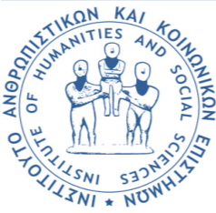The board of directors

The president The general secretary
Eleni P. Maraki Georgios E. Striligkas
MSc, PhD, Teaching Counselor (PE70) MSc, Teaching Counselor (PE01)

